Configuring Dynamic NAT

HOW TO CONFIGURE DYNAMIC NAT

Inacio Andre

2024

// TOPOLOGY //

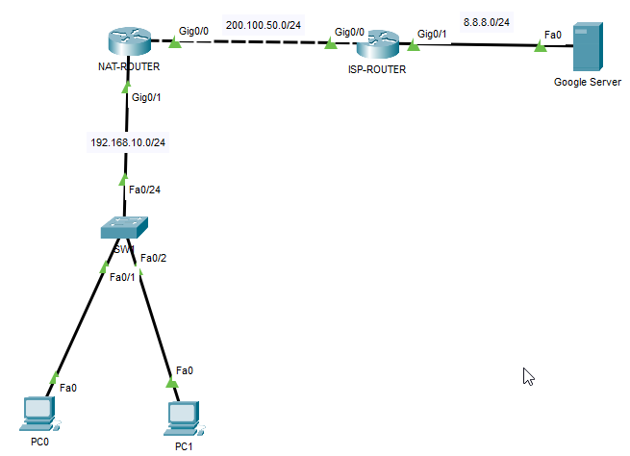

// BASIC CONFIGURATION //

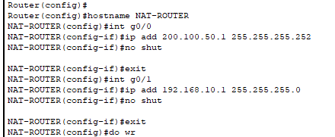

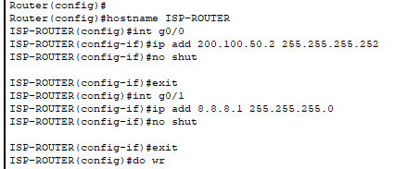

// OSPF CONFIGURATION //

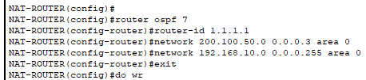

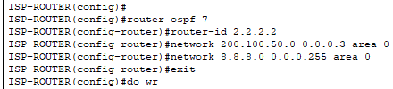

//TESTING COMMUNICATION //

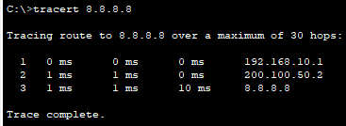

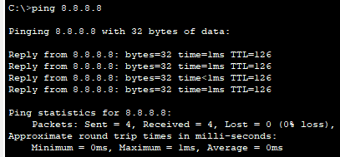



// NAT CONFIGURATION //

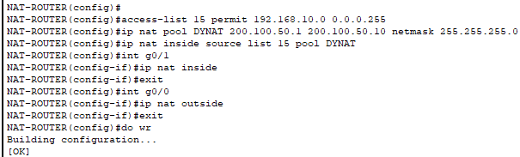

// TESTING COMMUNICATION AFTER NAT //

PC 0 TO GOOGLE SERVER

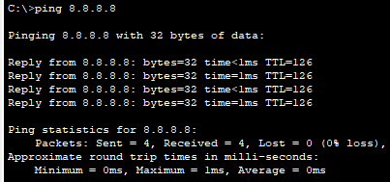

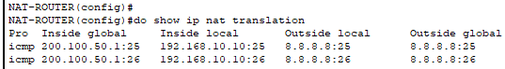

PC1 TO GOOGLE SERVER

